DOCUMENTATION

**DETAILS**

**TEAM MEMBERS NAME:**

* 1. AARUDHRA GOPI G
  2. KEERTHIKA R
  3. SNEHA R A
  4. SAKTHI NIVEHA R

**DEGREE/BRANCH**: B.E/CIVIL ENGINEERING

**INSTITUTE NAME:** VELAMMAL COLLEGE OF ENGINEERING AND TECHNOLOGY VIRAGNOOR MADURAI-625 009

**SKILLS**: DIGITAL MARKETING

**Project Details**

**Mail**

* **E-mail**: [earthelements@gmail.com](mailto:earthelements@gmail.com)
* **Password**: KASS2023

**WordPress Site**

* **Site Name**: ACS Elements
* **Site Address**: https://earthelements20231.wordpress.com/
* **Blog Name**: AAC Blocks
* **WordPress Blog URL**: <https://earthelements20231.wordpress.com/2023/10/18/aac-blocks/>

**Facebook Account**

* **Facebook Id**: https://[www.facebook.com/profile.php?id=61552796062274&mibextid=ZbWKwL](http://www.facebook.com/profile.php?id=61552796062274&mibextid=ZbWKwL)

Opening the WordPress site

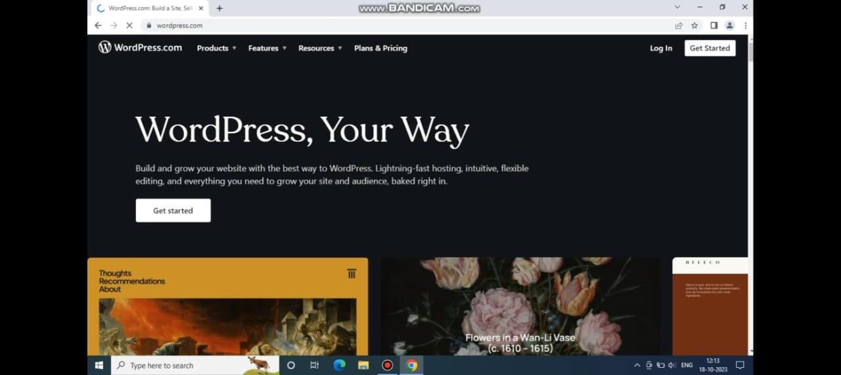

Creating an account for our brand in

WordPress

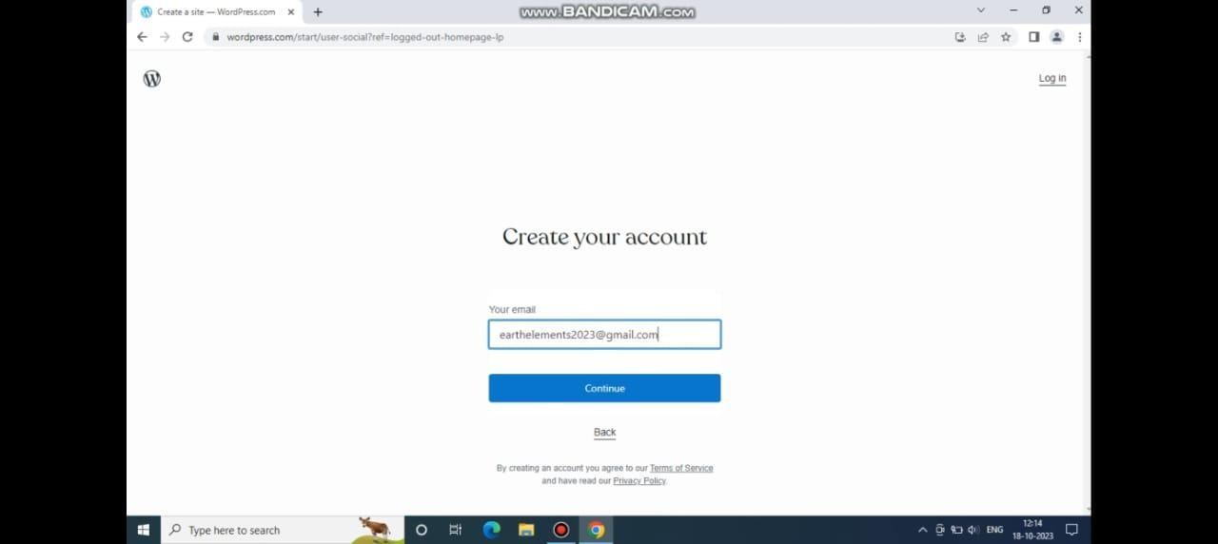

# Choosing our Goals

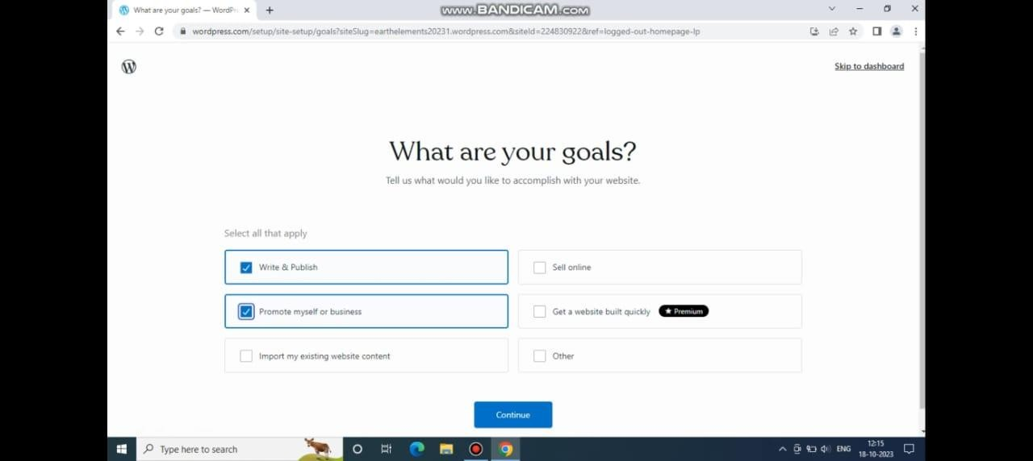

Blog content from AI Platform

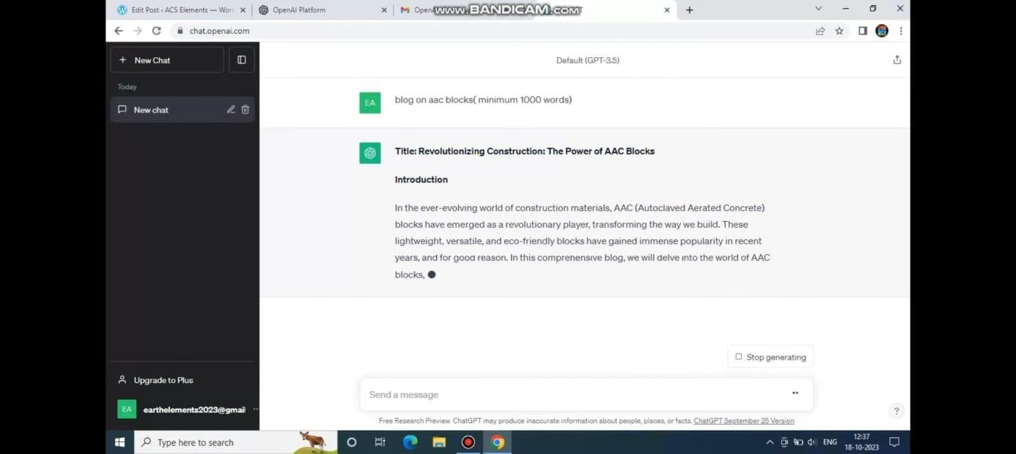

Importing the content to WordPress

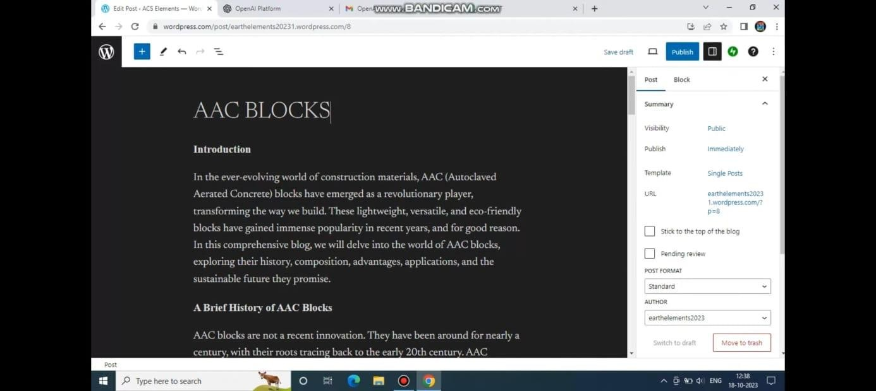

# Publishing our first post

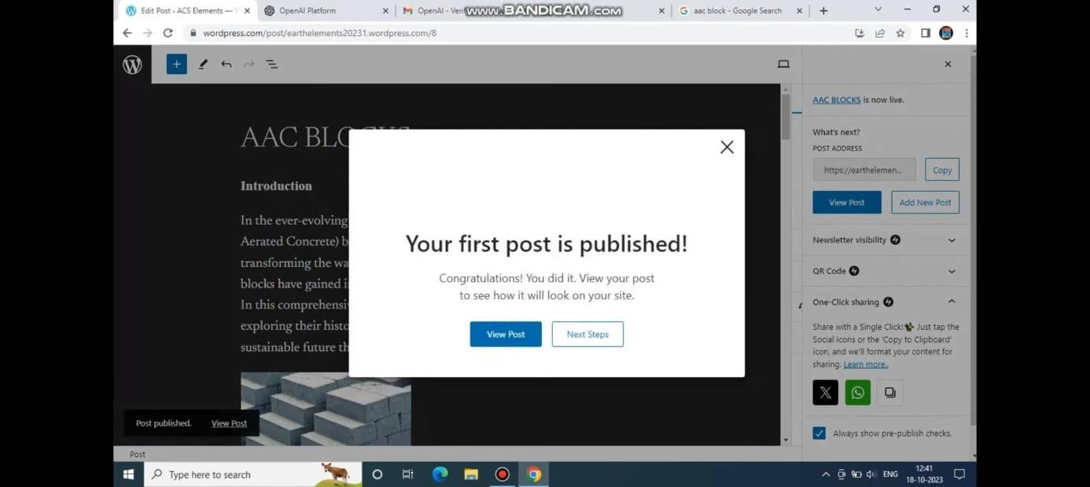

Changing new themes

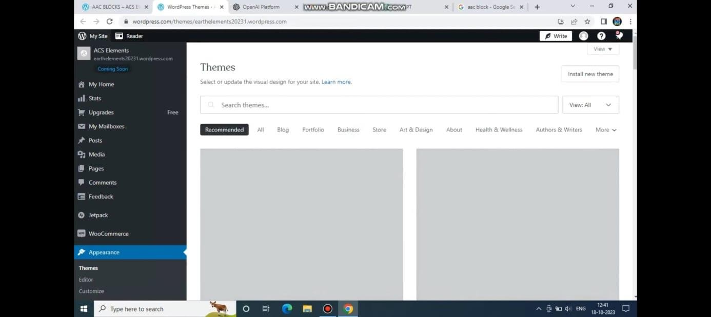

# Previewing our post

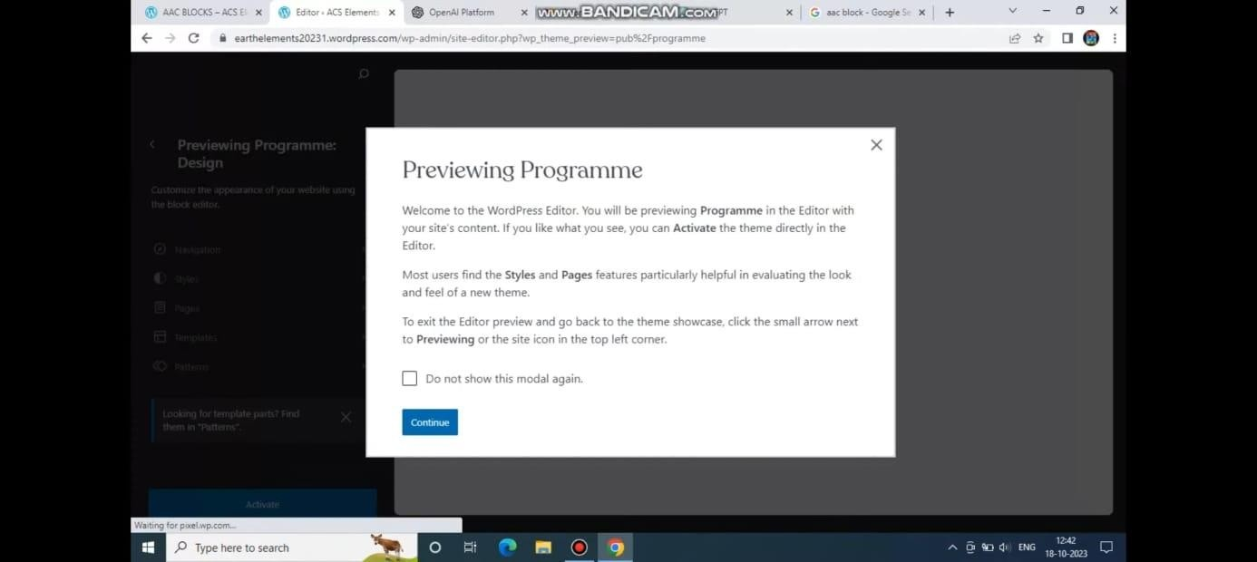

Account settings in WordPress after

publishing

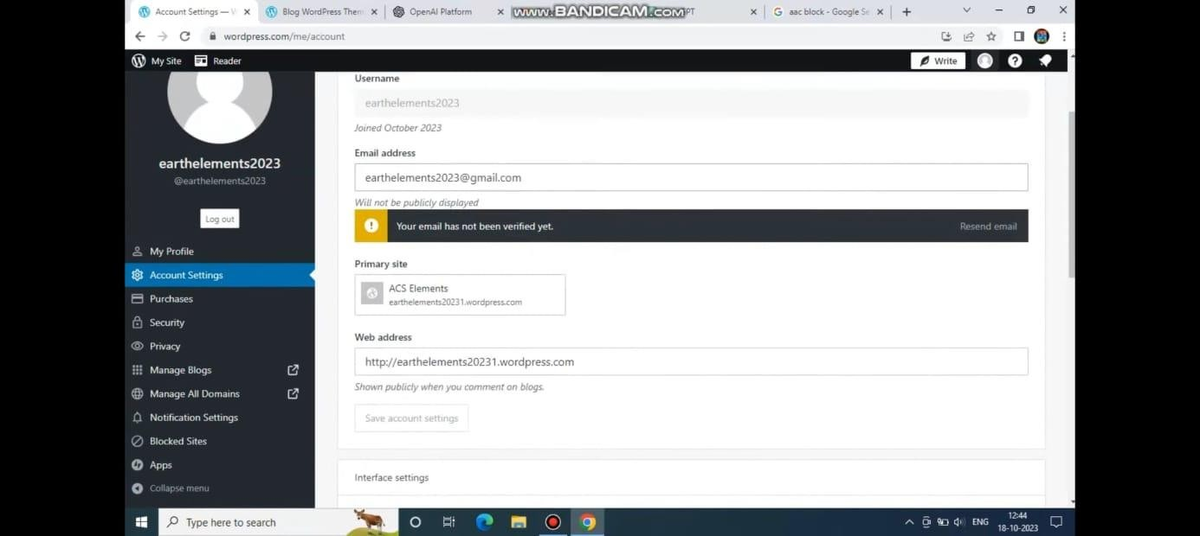

Creating a Business Account for our

brand in Facebook

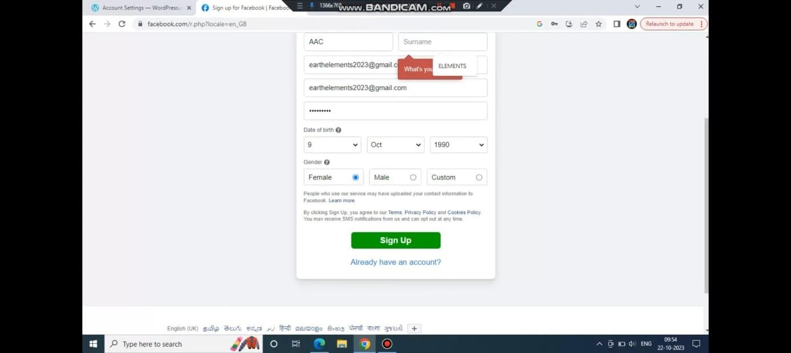

Creating a post our brand in facebook

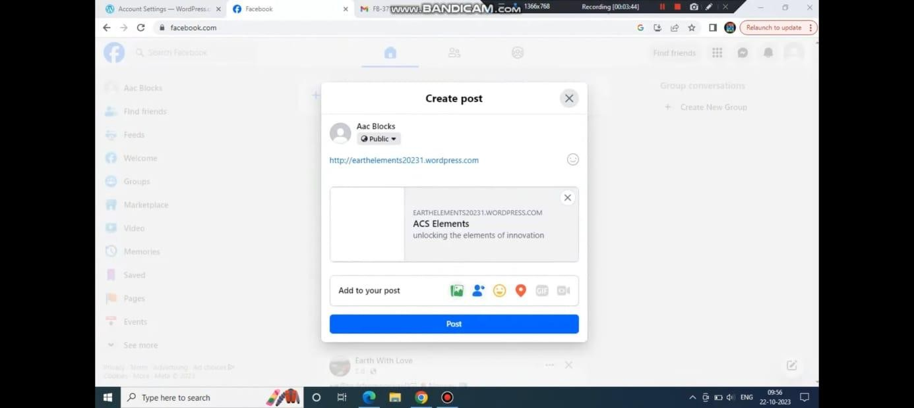

# Posting the Blog URL in facebook

